Added the Langfuse keys to RAG
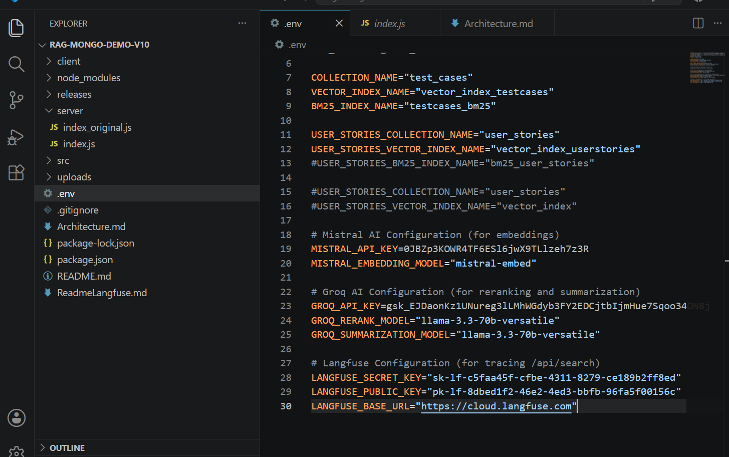
Did npm install and then nmp run dev to make the application up and running
Did vector search
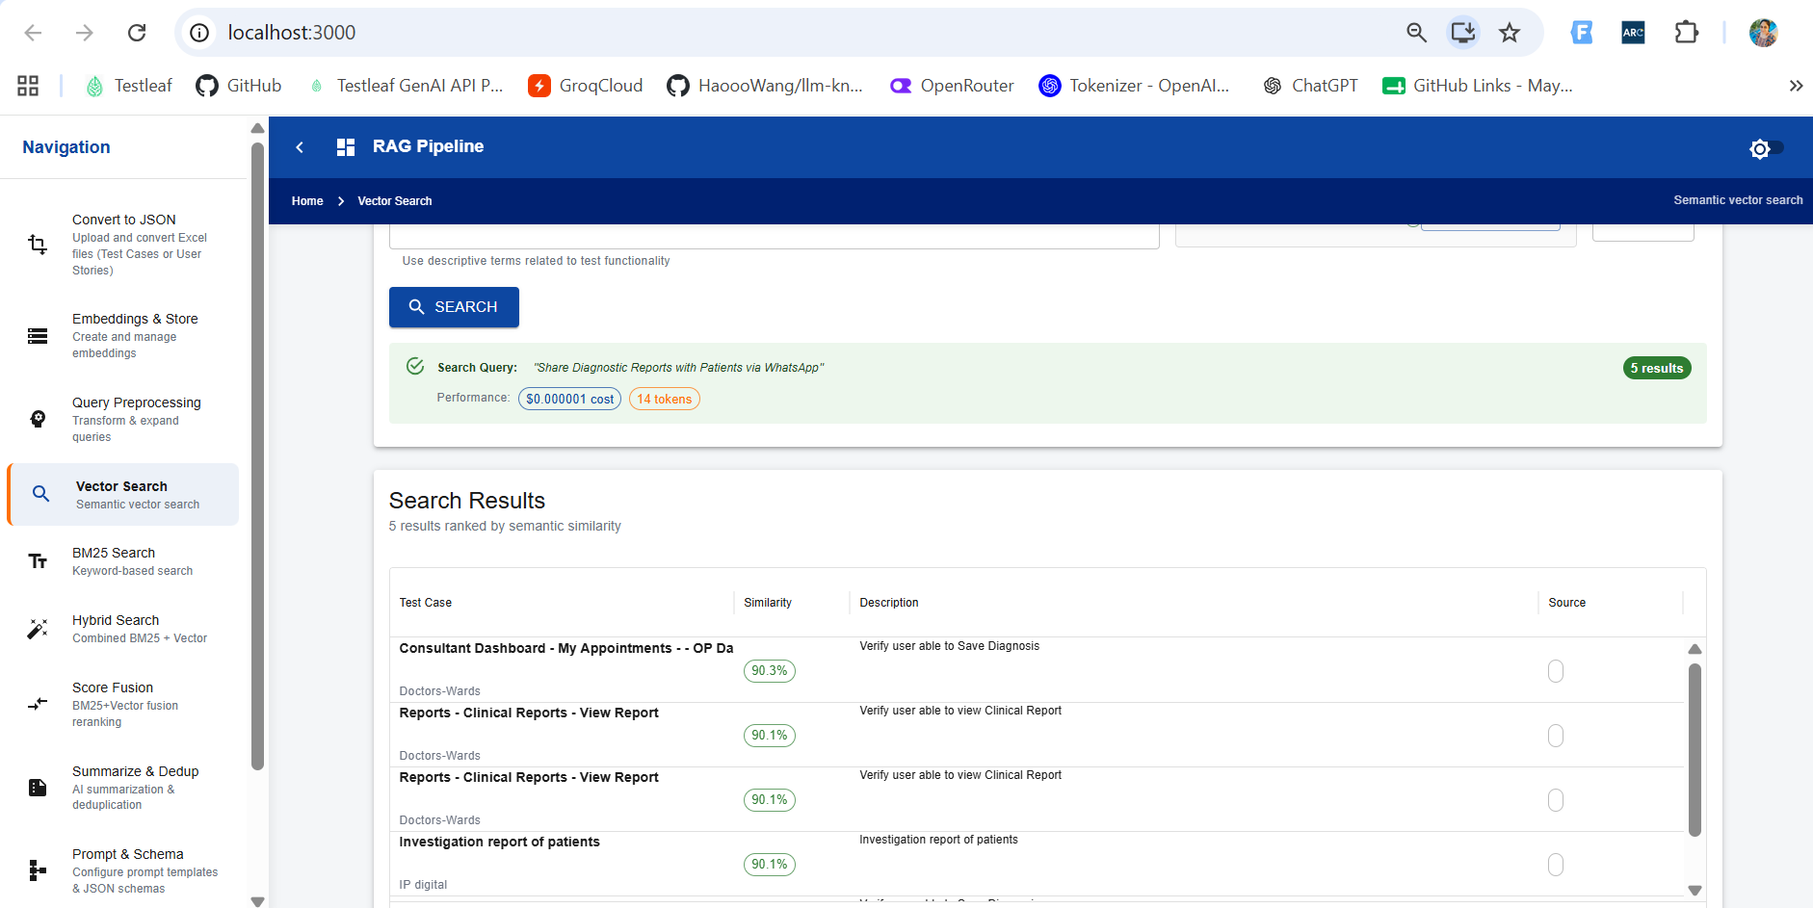
Verified the trace in LangFuse
